DIOMO KABONGO, the Troubled Congolese Youth Labourer
HOPES & DREAMS
A better relationship with his family
Further his education and become a lawyer, his childhood dream
Assist his family financially
Travel outside Congo
Marry a girl as pretty as Bibi and have his own family someday

WORRIES & FEARS
The worsening relationship with his family
Not being able to get out of his present circumstances
His temper leading him to do something terrible like fatally stab someone
His growing dependence on weed/marijuana

A DAY IN THE LIFE OF DIOMO
Leaves home around noon to job-hunt at construction sites
Spends afternoons/evenings with other youths at a local joint or in home of one of the youths
Returns home late in the night or early hours of the next day
Uses his cheap Android phone to browse the internet and job hunt
BACKGROUND
18 years old
Single
Lives in Kasai with mother, four younger siblings and an aged grandmother
Frequently gets into fights at home and in the community
Has been in police custody a few times in the past year
Out of school for three years
Has run away from home twice
Sometimes works as a labourer, but has difficulty in keeping a job and is presently out of work

WHAT HE’S LOOKING FOR
A place where he feels loved and understood
A sense of stability in his chaotic world
A better relationship with his mother, siblings and grandmother
A steadfast job that provides regular income so he doesn’t have to ask his mother for money or steal from her
A smartphone that could help him learn

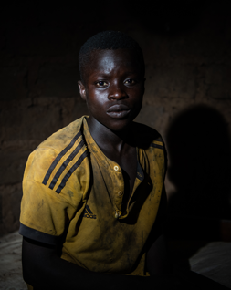

“My grandmother calls me a demon child because I get into fights, but people push me to act the way I do. No-one in my family understands me and it’s hard to talk to my mother!”

ZAWADI MWANGI, the Bone-weary Kenyan Domestic Worker
BACKGROUND
37 years old
Married
Lives in Kikuyu town with husband, their four children and a brother-in-law
Works in Nairobi as a domestic for a family while husband is a struggling farmer in Kikuyu
Physically tired, and stressed about family financial needs
Recently diagnosed with high blood pressure
Constantly in conflict with teenage son and daughter over their behaviours, poor grades, and choice of friends

WHAT SHE’S LOOKING FOR
A way to better manage her relationships with her children
A peaceful home where disagreements can be resolved without angry words and violence
Knowledge to manage finances so she doesn’t have to worry so much about money
Parenting tips that work; her co-worker’s advice only worsened matters

HOPES & DREAMS
Become a better mother and wife
Learn to communicate with her children without shouting and hitting them when upset
Stop worrying so much about financial needs
Raise capital and start a business

WORRIES & FEARS
Her teenage son doing drugs or getting into serious trouble; he often stays out late
Teenage daughter getting pregnant; she no longer listens to her advice
Her health getting worse
Inability to pay their bills

A DAY IN THE LIFE OF ZAWADI
Wakes up 4.30 am to plan the day and prepare meals for family
Gets on the 6 am bus to Nairobi to arrive work by 7 am
Returns home around 7 pm
Cooks dinner, does laundry, and attends to family’s needs till 10 pm
Uses smartphone given by her employers to read messages and watch videos on the church women’s WhatsApp group

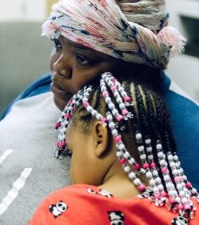

“My father said he named me Zawadi because I am a gift to the world, but I don’t think I am a gift to anyone. I’m exhausted after work and scream at my children even though it’s not their fault that life is so hard! I wish I could do better, but I don’t know how.”

OLUSEGUN ADEYEMI, the Successful Nigerian Banker
HOPES & DREAMS
Build a close and strong relationship with all his children
Have a loving and peaceful atmosphere at home
To become a friend and confidant to all his children

WORRIES & FEARS
His deteriorating relationship with his children
He is becoming the kind of man his own father was: distant and unapproachable
His children hanging out with the wrong crowd and not turning out well; his son has started keeping late nights
That his children will not visit or call him when they finally leave home

A DAY IN THE LIFE OF OLUSEGUN
Leaves for work at 7 am and spends a greater part of the day in his office
Plays golf after work most evenings
Returns home late in the evening and watches TV until he goes to bed
Thinks about what his kids do online with their iPhones
BACKGROUND
52 years old
Married
Lives in Lagos with wife and three teenage children
Works as a banking executive
Never had a good relationship with his father and always dreamed of being the ideal father
Last two annual vacations abroad were a complete disaster: always yelled at children for constantly having earphones on and they further withdrew from him
Always thought parenting was a woman’s job but not sure anymore
Feels terrible that his children now avoid being in the same space with him

WHAT HE’S LOOKING FOR
A way to forge a closer relationship with his children
Knowledge of how to resolve conflicts with his children without resulting to yelling
How to get advice on parenting without asking family or friends as that isn’t manly
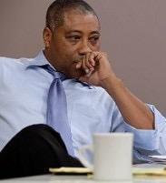

“I love my family and would love to have a close relationship with my children but that seems impossible. As they get older, they no longer want to involve me in their lives and this leaves me angry and frustrated!”

BINTA SESAY, the Unhappy Sierra Leonean Waitress
BACKGROUND
15 years old
Single; has 6-month old daughter
Lives in Lunsar in Port Loko District in Northern Sierra Leone with father, stepmother, two older sisters and three younger half-siblings
Mother died of Ebola in 2014
Father is a poor miner
Got pregnant from a relationship with an older man; needed money for textbooks and lunch
Quit school because pregnant girls banned from schools in Sierra Leone
Works as cleaner in a top restaurant to support child and self; stepmother and siblings look after baby when she’s at work
Has poor relationship with father and stepmother; they say she’s wayward and has brought shame to the family
Would love to get along with father and stepmother but doesn’t know how
Often sad and withdrawn; clams up when upset and cries when alone

WHAT SHE’S LOOKING FOR
Tips on how to better relate with father and stepmother
How to express her feelings when upset
How to manage what she earns and the money Abdul, the baby’s father, gives so these can meet all their needs

HOPES & DREAMS
Have a good relationship with her father and stepmother
Get a better paying job so she doesn’t have to call Abdul for money; he gives grudgingly
Return to school and study to become a teacher
Daughter will get education and become an important person in the society
Meet and marry a good man

WORRIES & FEARS
The poor relationship with her father may lead him to ask her to leave the house with her baby
That Abdul may disappear or stop sending her money
She may lose her job
She may never return to school or get a good job or career

A DAY IN THE LIFE OF BINTA
Gets up at dawn to bathe her baby and get ready for work
Leaves for the restaurant at 7am
During free time, uses cheap Android phone given by baby father to browse, or send messages to baby father or friends using WiFi of the restaurant
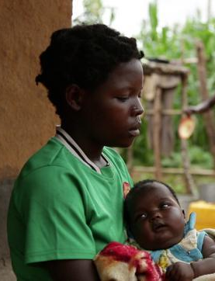

“I know I’ve brought shame to my family, but I am not wayward or any of the things they say I am. Even though they say things that hurt me, I love my father and stepmother and want to have a good relationship with them.”

LINDIWE NGOBENI, the South African Pensioner Grandmother
BACKGROUND
68 years old
Widow
Lives in Durban with two teenage grandchildren who came to live with her when orphaned from AIDS 10 years earlier
Pensioner who also receives child support grant for her grandchildren
Enjoyed a great relationship with grandchildren when they were young, but this changed as they became adolescents
Grandchildren have become disobedient and stubborn and leave her weary

WHAT SHE’S LOOKING FOR
How to get her grandchildren to listen to her
A way to stop cursing at her grandchildren when they upset her
How to better manage money so that she doesn’t have to occasionally turn to son to help out with some wants of the grandchildren

HOPES & DREAMS
Have a wonderful relationship with her grandchildren like it was when they were younger
For grandchildren to listen to her advice and avoid bad company
For grandchildren to grow into responsible adults
For grandchildren to get university education and good jobs

WORRIES & FEARS
Either or both grandchildren getting infected with HIV
Grandson getting into crime or getting hurt; he no longer tells her what he’s up to
Granddaughter has been given a smartphone from a sugar daddy
Either or both grandchildren dropping out of school

A DAY IN THE LIFE OF LINDIWE
Gets up 6 am to pray and wake grandchildren for school
Sometimes visits friends or relatives who live nearby
Uses her cheap Android phone to browse the internet, make calls and interact in WhatsApp groups
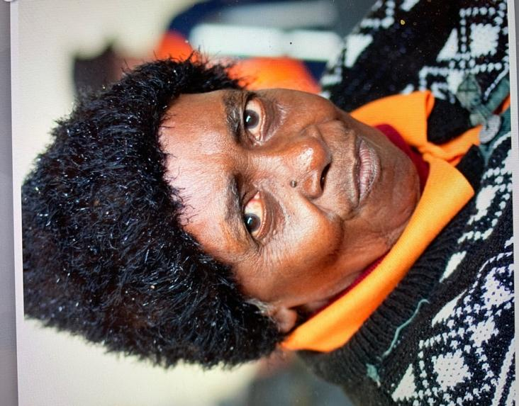

“I promised my late daughter that I would look after her two children and raise them well. It was okay when they were younger, but they act like strangers now. I feel like I have failed my daughter and I don’t know what to do.”

CHIBALE BANDA, the Orphaned Malawian Boy
BACKGROUND
14 years old
Single
Lives in Lilongwe with uncle, uncle’s wife and 4 younger cousins
Moved in with uncle when at age 8 he lost both parents and two siblings in a car accident
Uncle works as an NGO staff and wife is a secondary school teacher
Uncle and aunty doted on him in early years, but feel he’s become self-centred and difficult to manage
Often goes to friends’ houses without letting anyone know his whereabout
Doesn’t do his chores or homework unless reminded
Demands for luxury items that his friends have
Complains and sulks when he doesn’t get his way or is corrected

WHAT HE’S LOOKING FOR
A way to get his uncle and aunty to see things from his perspective
How to get his uncle and aunty to like him more; would really like to please them
How to get on with his family; hates being at odds with everyone at home

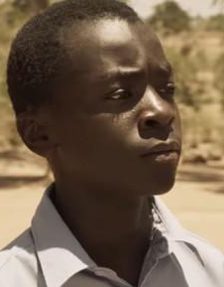
HOPES & DREAMS
A better relationship with his uncle and everyone at home
Do well in school and come first place; maybe that will get his uncle and aunty to like him more
Have cool clothes and stuff like his classmates so he can be among the cool kids at school
Complete secondary school and study in a university to become a doctor like his parents wanted

WORRIES & FEARS
He’s been increasingly getting into trouble at home
His uncle may not send him to university if they don’t have a good relationship
Not fitting in at school

A DAY IN THE LIFE OF CHIBALE
Goes to school with his cousins in the mornings
Returns from school around 2pm
Eats lunch and watches TV
Uses cheap Android phone to communicate with friends
Dashes out to a friend’s house to play video games till late evening

“Sometimes I like living with my uncle’s family and sometimes I don’t. Lately, I feel like they don’t care about how I feel. They scold me all the time and when I ask for things, they say there’s no money to buy those things! It’s just not fair!”

EFUA MENSAH, the Aspiring Ghanaian Actress
HOPES & DREAMS
An improved relationship with her parents
Become a successful actress like Jackie Appiah and Nadia Buari
Move to LA, land roles in Hollywood and become famous and rich like Angelina Jolie
Marry her boyfriend, Kofi, and get rid of all the girls that hang around him
Make her parents very proud of her
Become a role model to her siblings

WORRIES & FEARS
Worsening relationship with parents
Inability to land acting roles despite frequent auditions; she wants to make her own money
Not making a success of her life and having to depend on her parents all through
Kofi leaving her for another girl

A DAY IN THE LIFE OF EFUA
At parents’ insistence, leaves for extramural classes at 10am
Browses iPhone Kofi gave her; checks WhatsApp group for info on auditions
Leaves classes for auditions at noon
Spends evenings at Kofi’s pad
Returns home at night or late evening and tells parents she’s been at a girlfriend’s house studying
BACKGROUND
17 years old
Single
From a deeply religious lower middle-class family
Lives in Accra with parents and three younger siblings
Recently completed secondary school but didn’t get good grades
Parents want her to re-sit final exams, get better grades and study law at a university
Not interested in law or a degree; wants to become an actress
Sneaks out of home to attend auditions and lies to parents about her whereabouts
Dating musician in late-20s who has dreadlocks, multiple piercings on his face, and tattoos all over his body
Parents disapprove of boyfriend
Relationship with parents is very strained

WHAT SHE’S LOOKING FOR
A way to get her parents to have faith in her ability to make the right choices
Better communication with her parents; she usually slams the door and walks out when upset
Independence from parents


“My parents are very controlling. They want to know where I am every second of the day. They are also critical of my choices. I can never do anything right in their eyes. I feel guilty about lying to them, but I wish they would accept that I know what I want out of life and just let me be!”

HUSSEIN IBRAHIM, the Struggling Sudanese Farmer
HOPES & DREAMS
Build a close and strong relationship with his children
Have a loving and peaceful atmosphere at home
Expand his farm and make enough money to send his children to school

WORRIES & FEARS
He is losing control of the headship of his family
His sons are becoming more stubborn and may stand up to him in public one day
His children may become wayward and bring shame to the family name
The drought may seriously affect his farm and lead to the loss of his livelihood

A DAY IN THE LIFE OF HUSSEIN
Leaves for the farm early in the morning and works there till late morning
Goes home for lunch and some rest
Uses his old Nokia phone to make calls or text; also uses cheap Android phone of older sons to browse
Returns to the farm in the evening and works a few more hours there
BACKGROUND
58 years old
Married
Lives in Nagazou, Wad Hamid with his two wives and sixteen children
Works as a farmer, growing potatoes, tomatoes and other vegetables
Is helped on the farm by his wives and older children
Believes it is his responsibility as the man of the house to lead his household with a firm hand
Feels angry when his adolescent children disobey and whips them
Has a tumultuous relationship with his children and can’t understand why they won’t simply obey without arguing with him

WHAT HE’S LOOKING FOR
How to get his children to obey him
Knowledge of how to build a healthy relationship with his children
Knowledge of how to manage the income from his farm so he can take care of the needs of his family
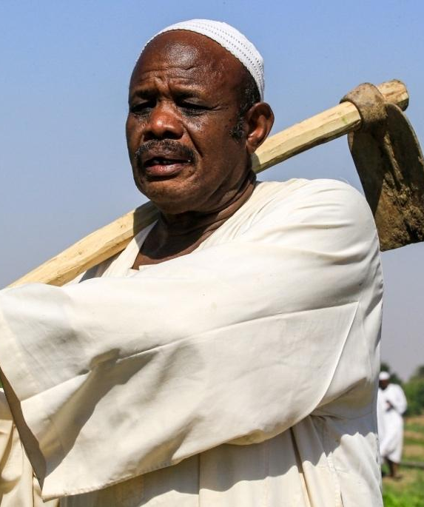

“It’s very difficult to understand the children of these days. They are stubborn and unwilling to listen to advice. As the head of the family, it’s my duty to tell my children what to do but they no longer listen to me. I am tired and don’t know what to do anymore!”

Sudan, Senegal

AÏSSATOU DIOP, the Ambitious Senegalese Nurse
BACKGROUND
45 years old
Married
Lives in Dakar with husband and three adolescent children
Works as a nurse in a government hospital
Husband teaches in a secondary school in Dakar
Enjoyed relationship with the children when they were younger, but this changed as they became adolescents
Has challenges in relating with the children as they are usually moody and difficult to get along with
Often screams at children and has hit them a few times

WHAT SHE’S LOOKING FOR
Tips on how to parent adolescents
A way to get her children to snap out of their moods and stop being self-centred
How to stop yelling at her children
How to better manage her emotions so the children’s behaviours don’t get to her
Knowledge of how to manage their finances so they can save more money

HOPES & DREAMS
Have a wonderful relationship with her children like she did when they were younger
For her children to snap out of their moods and become cheerful adolescents with great attitudes
For her children to grow into responsible adults
To be promoted to become the matron so she can earn much more than she currently does

WORRIES & FEARS
Relationship with children worsening such that they become strangers
Any of her children becoming a social misfit
Her children hanging out with the wrong crowd and getting into trouble; she doesn’t know most of their new friends

A DAY IN THE LIFE OF AÏSSATOU
Gets up at dawn to say her prayers
Wakes children to prepare for school
Leaves for hospital after breakfast
During free time, uses any of her 2 Android phones to communicate with family and/or friends and read chats in WhatsApp groups
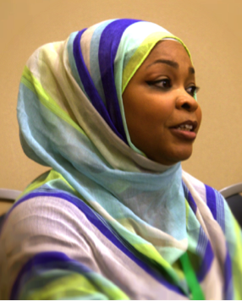

“My children used to be the sweetest and most lively children ever, but these days, they are in a world of their own. They drive me crazy with their constant sulking and adolescent tantrums and I can’t help yelling at them.”

HENRI MBA, the Conflicted Gabonese Teenage Father
BACKGROUND
17 years old
Single
Lives with lower middle-class parents and 4 siblings in Owendo
In final year of secondary school
Has one-year old son who lives with baby mama
Works part-time as a bar attendant to support his child
Struggles with schooling and working at the same time
Parents want him to quit work and solely focus on schooling
Baby mama says to quit school and work full time to support them
Has tumultuous relationship with parents; destroys things when upset
Sometimes hits baby mama during arguments but usually regrets this
Frequently smokes and drinks

WHAT HE’S LOOKING FOR
Guidance on what path to take
Improved relationship with parents
How to better manage his emotions so he doesn’t destroy things or hit baby mama when angry
How to better manage his income so he can provide for his son
A way to quit smoking

HOPES & DREAMS
Have a better relationship with his parents and siblings
Be a good father to his son
Go to university even though he doesn’t know what he’ll like to study
Get a job that pays well so he can take good care of his son
Stop smoking, drink less alcohol and be in control of his emotions

WORRIES & FEARS
Relationship with parents and siblings is getting worse
Baby mama might cut him off from his child if he stops giving support
He might injure baby mama one day and get locked up in jail
He may not amount to anything
Dependence on cigarette and alcohol when stressed, which is often

A DAY IN THE LIFE OF HENRI
Goes to school in the mornings
Returns from school around 3.30pm
Leaves for work at 4pm and works for 4 hours
Uses his cheap Android phone to browse the internet on and off within the day, at school and at work
Gets home around 8.30pm, eats dinner and studies when not too tired
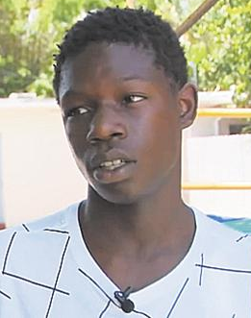

“Nothing has turned out the way I expected. I want to be a good father to my son and a good son to my parents, but I feel not really ready for any of these. It gets me angry that everyone’s trying to get me to do what they want without thinking about what I want!”

ANA LUKAMBA, the Zealous Angolan Women’s Fellowship President
BACKGROUND
54 years old
Married
Lives with husband and 5 children in the outskirts of Luanda
Owns and runs the most popular eatery in her locality
Husband works in one of the oil rigs in Luanda
Very active in her local church
Was elected the president of the church’s Women’s Fellowship group last year
Women in church and the local community regularly go to her for advice on relationship problems with their husbands and children
Sometimes feels inadequate to help the women as she has no formal training in counselling

WHAT SHE’S LOOKING FOR
A way to get some sort of training on Guidance and Counselling
A channel through which she could regularly receive effective relationship tips that she could share with the women
Knowledge of how to support the women to achieve their different goals

HOPES & DREAMS
Become an excellent leader under whose tenure the fellowship will grow numerically and otherwise
Be renowned for godly wisdom and sound counsel
Get formal training and become a certified counsellor

WORRIES & FEARS
That her counselling may not be very effective; some of the women she counselled have not reported that the counselling helped
That people may stop attending the Women’s Fellowship meetings or leave the church altogether if they find another fellowship that better caters to their needs; lately, numbers have dwindled at the meetings

A DAY IN THE LIFE OF ANA
Wakes up at 5am to read the Bible and pray; later joins the family for devotion
At 7am, leaves for eatery where she supervises staff to prepare food and attend to different customers
During less busy periods, posts on the Women’s Fellowship WhatsApp group and counsels women who call or visit
Returns home around 6pm; attends to family & sometimes friends till 10pm
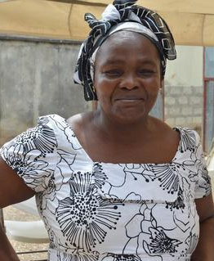

“Many women in my church come to me for guidance when they have problems with their husbands and children. I pray with them and also counsel them using the scriptures, but I wish I had tips to regularly share with all the women during our meetings as these would help everyone.”

HAROUNA DAOUDA, the Devoted Nigerien Researcher
BACKGROUND
28 years old
Single
Lives in Niamey with his 27-year-old cousin who works in a telecoms company; they jointly rent the apartment
Works as a researcher in the Abdou Moumouni University, Niamey
Presently researching the effectiveness of digital interventions in Sub-Saharan African countries
Eager to discover if digital interventions work in typical African communities
Keen on sharing findings through publications in reputable journals

WHAT HE’S LOOKING FOR
Digital interventions that are aimed at Sub-Saharan African countries
How to track the effectiveness of the interventions on users in different African communities and see if there are similarities and/or differences in the impact
HOPES & DREAMS
Make his mark as an excellent researcher
Win large grants and conduct studies that have the potential to greatly impact the lives of many Africans
Get published in reputable international journals

WORRIES & FEARS
Not getting rich data or significant findings from current study
Not winning any substantial grant; his applications for large grants have all been unsuccessful
Not getting published in a renowned journal

A DAY IN THE LIFE OF HAROUNA
Wakes up at 6am, checks phone for news, then makes himself coffee
Leaves for the university at 8am
Does some desk-based research on digital interventions
Makes calls and responds to WhatsApp messages
Hangs out with girlfriend from about 6pm then heads home


“I know that digital interventions work in developed nations but that’s no proof that they will work here. I think that it’s important for us to investigate and know what works for us before we adopt any new thing and I hope to have findings on this very soon!”

VIMBAI MOYO, the Bubbly Zimbabwean PLH Facilitator
BACKGROUND
44 years old
Single
Has two daughters who are in their twenties and a 14-year-old son
Lives with older daughter and son in Bulawayo Province
Works with the NGO, CWBSA, as a facilitator for the PLH for Teens programme
Enjoys delivering the PLH sessions and gets fulfilment from seeing the impact the programme has on both caregivers and adolescents
Sometimes gets tired of talking during the programmes and wishes there could be an alternative mode of delivery she could sometimes switch to

WHAT SHE’S LOOKING FOR
Something that could make her job as a facilitator less demanding and just as effective
A way to meet participants demands for the continual delivery of the PLH programme beyond the 14 sessions

HOPES & DREAMS
To excel as a facilitator and begin to train other facilitators
To reach many more communities with the PLH programme and see many families transformed

WORRIES & FEARS
That she may become less effective as a facilitator over time
That the demand of having to speak throughout the different PLH sessions may affect her health; lately, she sometimes feels tired after facilitating for about 30 minutes

A DAY IN THE LIFE OF VIMBAI
Wakes up around 6 am and gets everyone up and ready for the day
Checks her phone for emails and WhatsApp messages while eating breakfast
Leaves for office at 8am and spends about an hour there
Heads out to the venue for the PLH for Teens programme
Spends a greater part of the day facilitating a PLH session
Spends time with children before retiring for the day
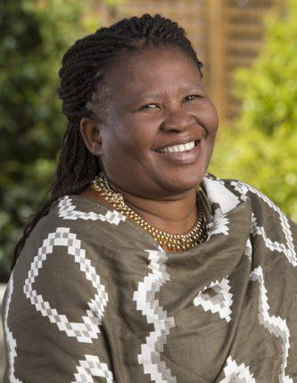

“I love my job as a facilitator and really enjoy going through the PLH sessions with caregivers and adolescents but it’s sometimes tiring having to talk so much during a session. I wish there was a way to deliver some sessions without speaking all the time.”

GAHIJI UWIMANA, the Rwandan M&E Officer
HOPES & DREAMS
To excel in his career and become an M&E manager for a local NGO
To eventually work in M&E for one of the big global donors in Africa such as USAID, Global Fund or UNDP.

WORRIES & FEARS
That the NGO may not meet the complex M&E requirements of different funders
That he may not be able to report quality data on time to ensure that the NGO retains funding

A DAY IN THE LIFE OF GAHIJI
Wakes up at 6.30 am
Leaves for work after breakfast
When not in the field visiting the NGO’s implementation sites to collect and verify data and provide M&E technical support to staff, spends a greater part of the day at desk, creating M&E tools, analysing data and writing donor reports
Uses Android phone to make calls to relevant staff
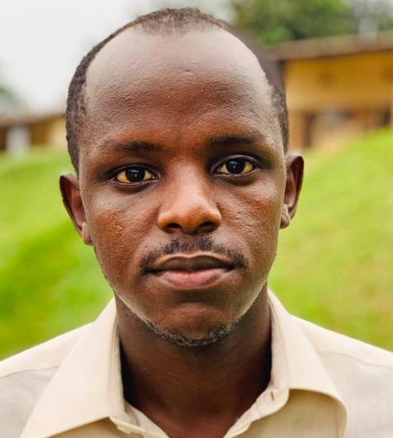

“My job as an M&E officer would be so much easier if there was a way to digitally monitor and evaluate the implementation and outcomes of interventions. This is one of the reasons I am excited about digital interventions; I can’t wait to track the impact of the PLH app!
BACKGROUND
35 years old
Married
Lives with wife and three children in Kigali
Works as an M&E officer in an NGO in Kigali
A detail-orientated person, who enjoys working with data and statistics
Gets fulfilment from seeing monitoring data being used to support and improve the implementation of programmes

WHAT HE’S LOOKING FOR
Something that will help to lessen the large number of paper forms the NGO has to use across their different programmes
A simpler system for collecting and verifying routine monitoring data to report to funders
Something that automatically tracks programme outcomes, so the organisation doesn’t have to find additional funds to implement programme evaluations

